Description of the catchment BRUE

The Brue catchment is located in South West of England, UK. This catchment has been extensively used for research on weather radar, quantitative precipitation forecasting and R-R modelling, as it has been facilitated with a dense rain gauge network as well as coverage by three weather radars. Numerous studies (Bell and Moore, 2000; Moore, 2002) have been conducted regarding the catchment, notably during the period of the Hydrological Radar EXperiment (HYREX) which was a UK Natural Environment Research Council (NERC) Special Topic Program. Figure shows the locations of the Brue catchment and the gauging stations. The major land use is pasture on clay soil and there are some patches of woodland in the higher eastern part of the catchment.
The catchment has a drainage area of 135 km² with the average annual rainfall of 867 mm and the average river flow of 1.92 m³/s, for the period from 1961 to 1990. Besides weather radar, there is a dense raingauge network which comprises 49 Cassella 0.2 mm tipping-bucket raingauges, having recording time resolution of 10 seconds (Bell and Moore, 2000). The network provides at least one raingauge in each of the 2 km grid squares that lie entirely within the catchment. The discharge is measured at Lovington.

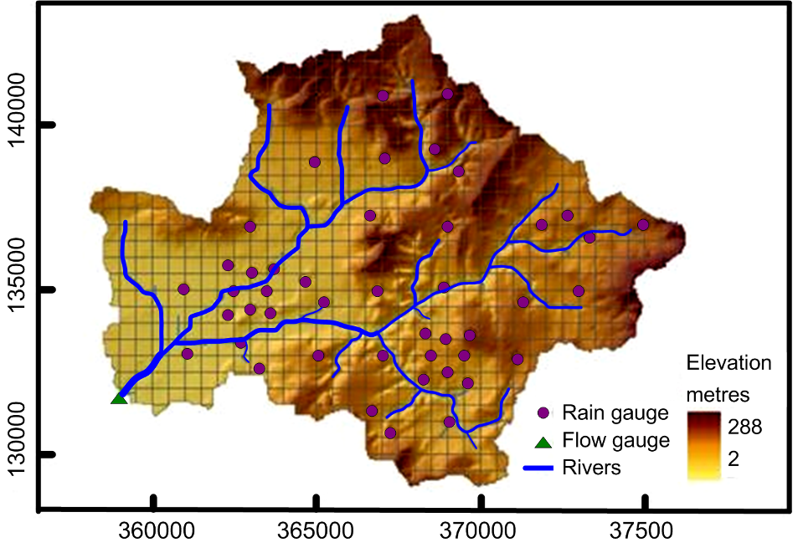
Figure 1. The Brue catchment showing dense rain gauges network (the horizontal and vertical axes refer to the easting and northing in British national grid reference co-ordinates).
The hourly data of rainfall, discharge, and automatic weather data (temperature, wind, solar radiation etc.) was computed from the 15 minutes data. The basin average rainfall data was used in the study. The hourly potential evapotranspiration was computed using the modified Penman method recommended by FAO (Allen et al., 1998) One year hourly data from 1994/06/24 05:00 to 1995/06/24 04:00 was selected for calibration of HBV hydrological model and data from 1995/06/24 05:00 to 1996/05/31 13:00 was used for the validation (testing) of the hydrological model. Each of the two data sets represents almost a full year of observations.

HBV model

We use simplified version of HBV (Bergström, 1976) model as rainfall-runoff model shown in Figure 2. The HBV model is a lumped conceptual hydrological model which includes conceptual numerical descriptions of hydrological processes at catchment scale. HBV model is setup with nine parameters excluding four parameters of snow.

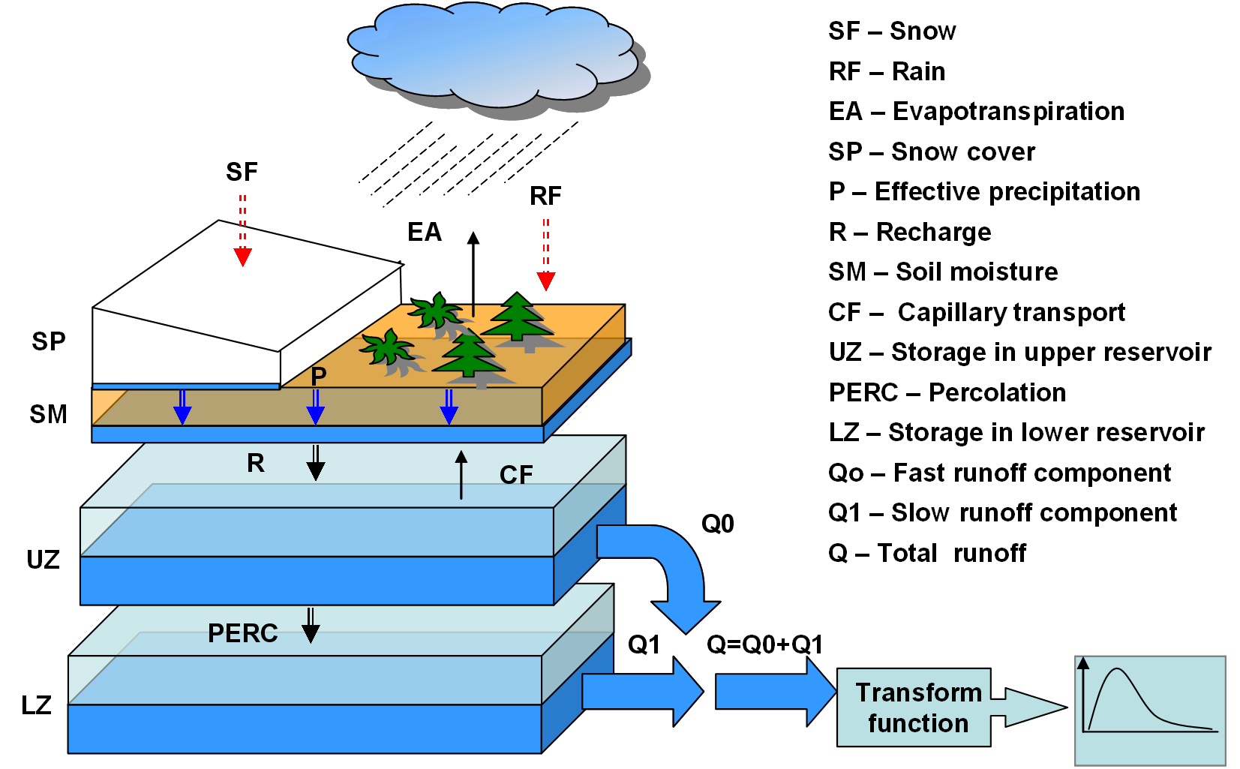

Figure 2.Schematic representation of the HBV-96 model (after Lindström et al., 1997) with routines for snow, soil, and runoff response.

The ranges of parameters values for automatic calibration and uncertainty analysis are set based on the ranges of calibrated values from the other model applications (e.g., Braun and Renner, 1992) and the hydrologic knowledge of the catchment. The ranges are extended when the solutions were found near the border of the parameter ranges and re-calibration of the model is done with the extended ranges of the parameters. Sometimes automatic calibration gives the parameter values which do not represent the physical process well in all situations. Therefore, manual fine tuning of the parameters follows the automatic procedure by visual comparison of the observed and simulated hydrographs.

Automatic global optimization routine GLOBE (Solomatine, 1999) is used to fine optimal parameter value. The model is calibrated using the Nash -Sutcliffe model efficiency, CoE (Nash and Sutcliffe, 1970) as a performance measure of HBV model. CoE value of 0.96 is obtained for the calibration period. The model was validated by simulating the flows for the independent verification data set, and CoE is 0.83 for this period. Error: Reference source not found shows the observed and simulated hydrograph in a part of calibration and in verification period.

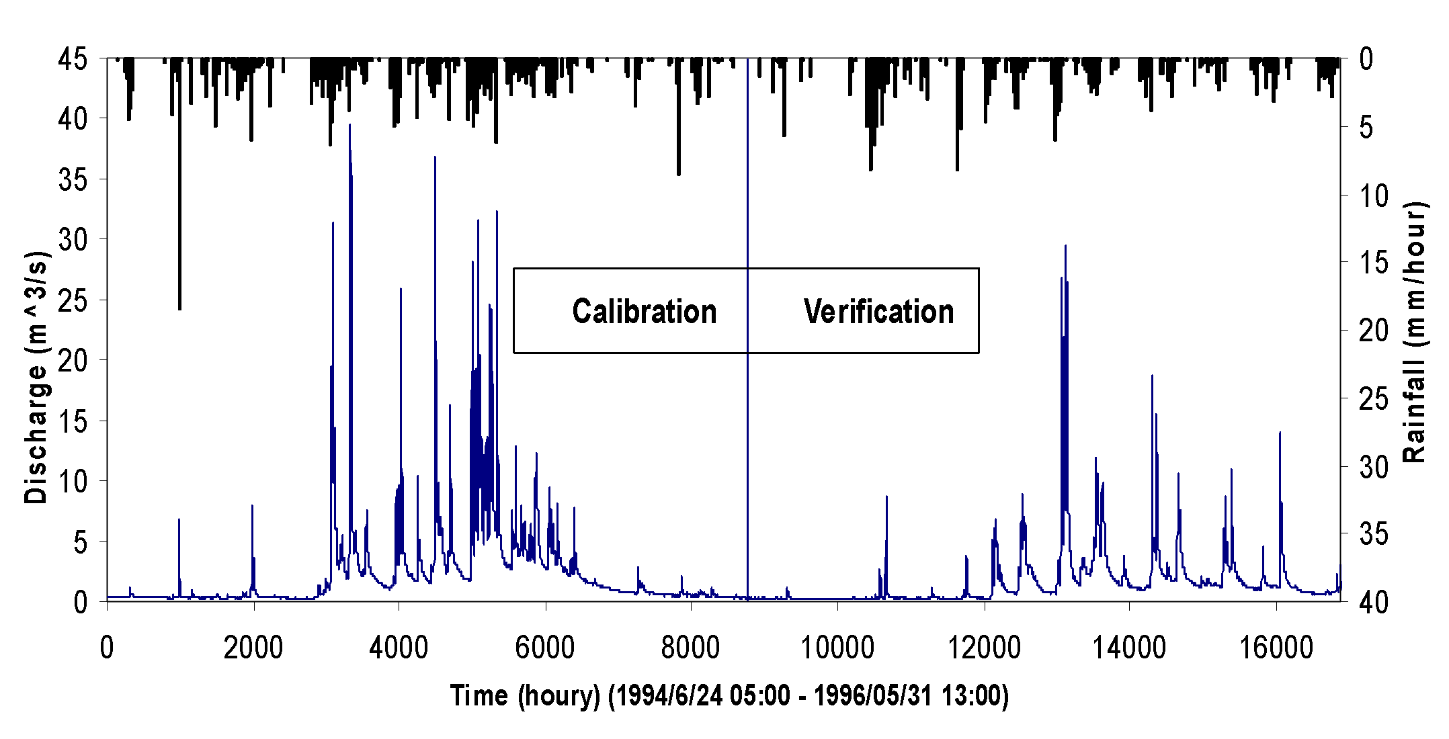
Figure 3: Relationship between rainfall and runoff
References
Allen RG, Pereisa LS, Raes D, Smith M. (1998). Crop evapotranspiration, guideline for computing crop water requirements, FAO, Irrigation and drainage paper 56: 300
Braun LN, Renner CB. 1992. Application of a conceptual runoff model in different physiographic regions of Switzerland, Hydrological Science Journal 37: 217–232
Bergström, S. (1976). Development and application of a conceptual runoff model for Scandinavian catchments, SMHI, Report No. RHO 7, Norrköping, 134 pp.
and test of the distributed HBV-96 hydrological model, Journal of hydrology, 201, 272-288.
Bell, V.A. and Moore, R.J. (2000). The Sensitivity of Catchment Runoff Models to Rainfall Data at Different Spatial Scales, Hydrology and Earth System Sciences, 4(4), 653–667.
Bergstrom, S., (1990). Parametervàrden for HBV-modellen i Sverige, Erfarenheter frân modelkalibreringar under perioden 1975-1989 (Parameter values for the HBV model in Sweden, in Swedish). SMHI, no. 28, Norrkoping, 35 pp.
Lindstrom, G., Johansson. B., Magnus P., Gardelin, M., and Bergstrom, S. (1997). Development Moore, B. (2002). Special Issue: HYREX: The Hydrological Radar Experiment, Hydrology and Earth System Sciences, 4(4), 521–522.
Nash, J. E., and Sutcliffe, J.V. (1970). River Flow Forecasting Through Conceptual Models Part 1 – A Discussion Principles, Journal of hydrology, 10, 282–290.
Solomatine D.P.(1999). Two strategies of adaptive cluster covering with descent and their comparison to other algorithms, J. Global Opt., Vol. 14, No.1, pp 55-78.

